

USER MANUAL

Reset Password
MAHARASHTRA GST TAX DEPARTMENT



Submitted By,

Orient Technologies Limited

Formerly known as Orient Technologies Pvt. Ltd

Instruction to Onboard Existing Dealer into New System

Steps:

- Log on to website www.mahagst.gov.in
- Go to Respective Act Section.
- Click on the option "Login for Existing Dealer under VAT/CST Acts".

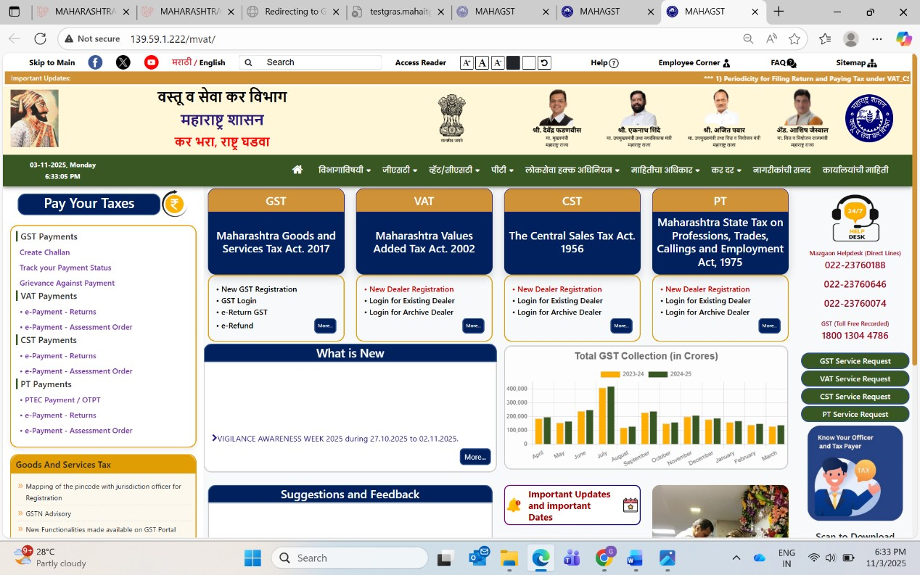

- "Login" page will open.
- Click on “Reset Password”.
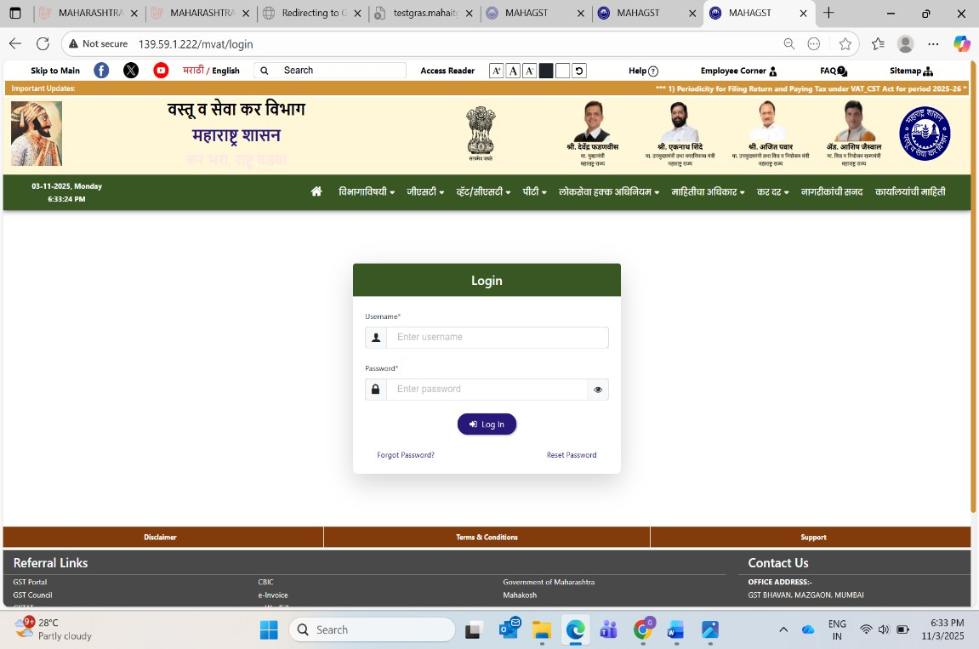

- Enter Valid “TIN” no Suffix V.
- Enter Valid “PAN”
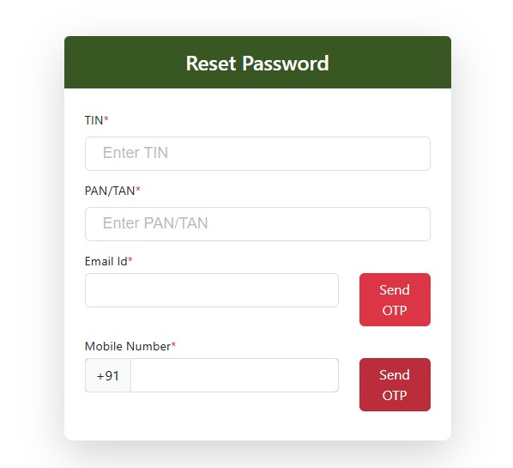

- Field Auto-populates Email ID and Mobile No , after entering TIN and PAN.
- Click on “Send OTP”.

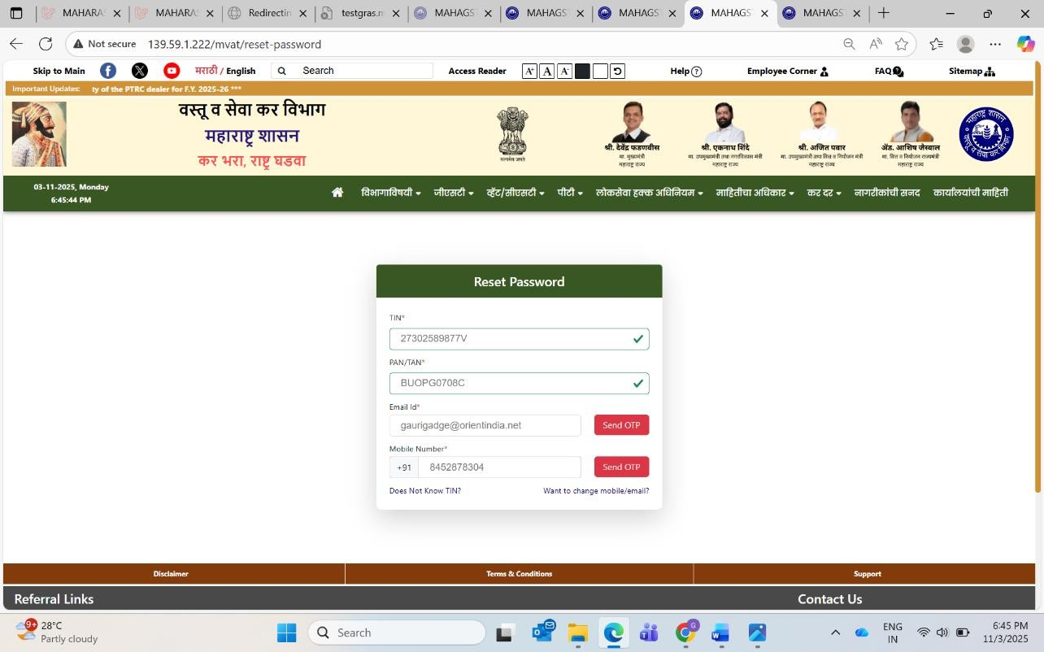

- OTP will be received on Email ID and Mobile No Verify it and submit. (For future communication)

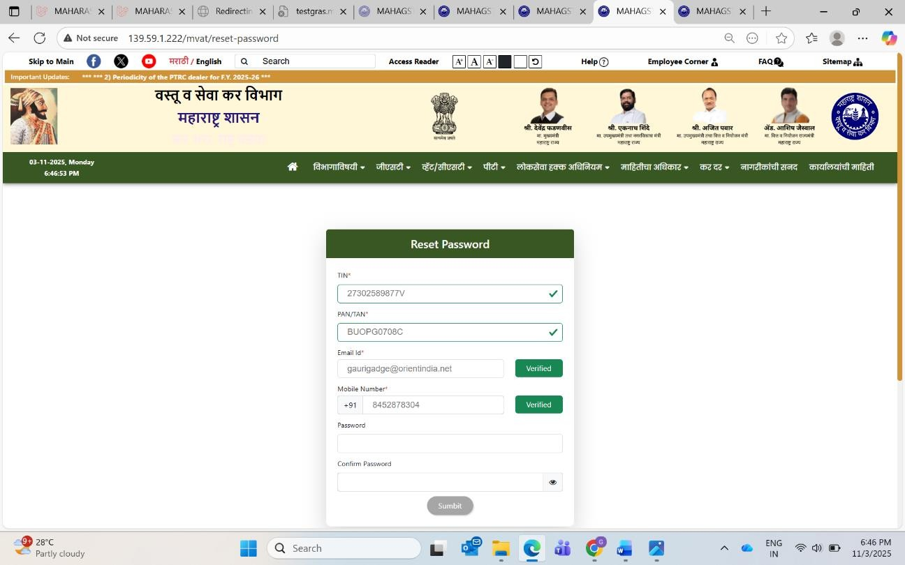

11.Enter Password
- Enter the Confirm password for confirmation.
- Click on “Submit” button.

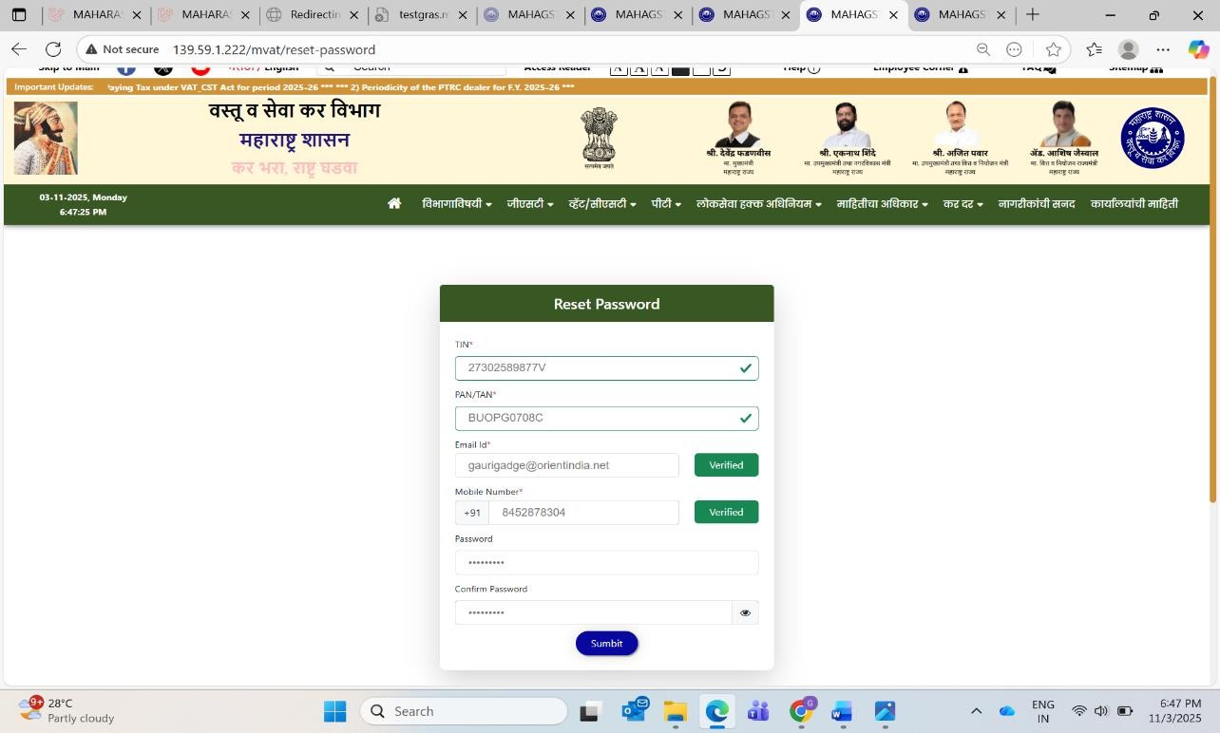

If you want to change Mobile No and Email ID, then

➢ 1. Click on “want to change Mobile/Email?”

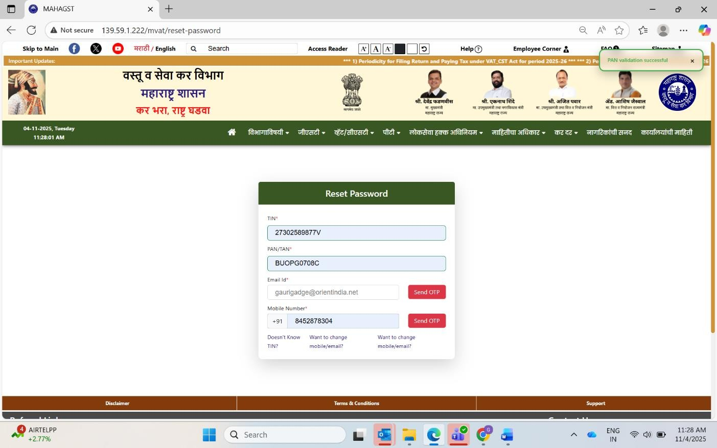

- Enter valid Email ID.
  - click on send OTP and verify it. Once verified, the field will display a green “Verified” status.
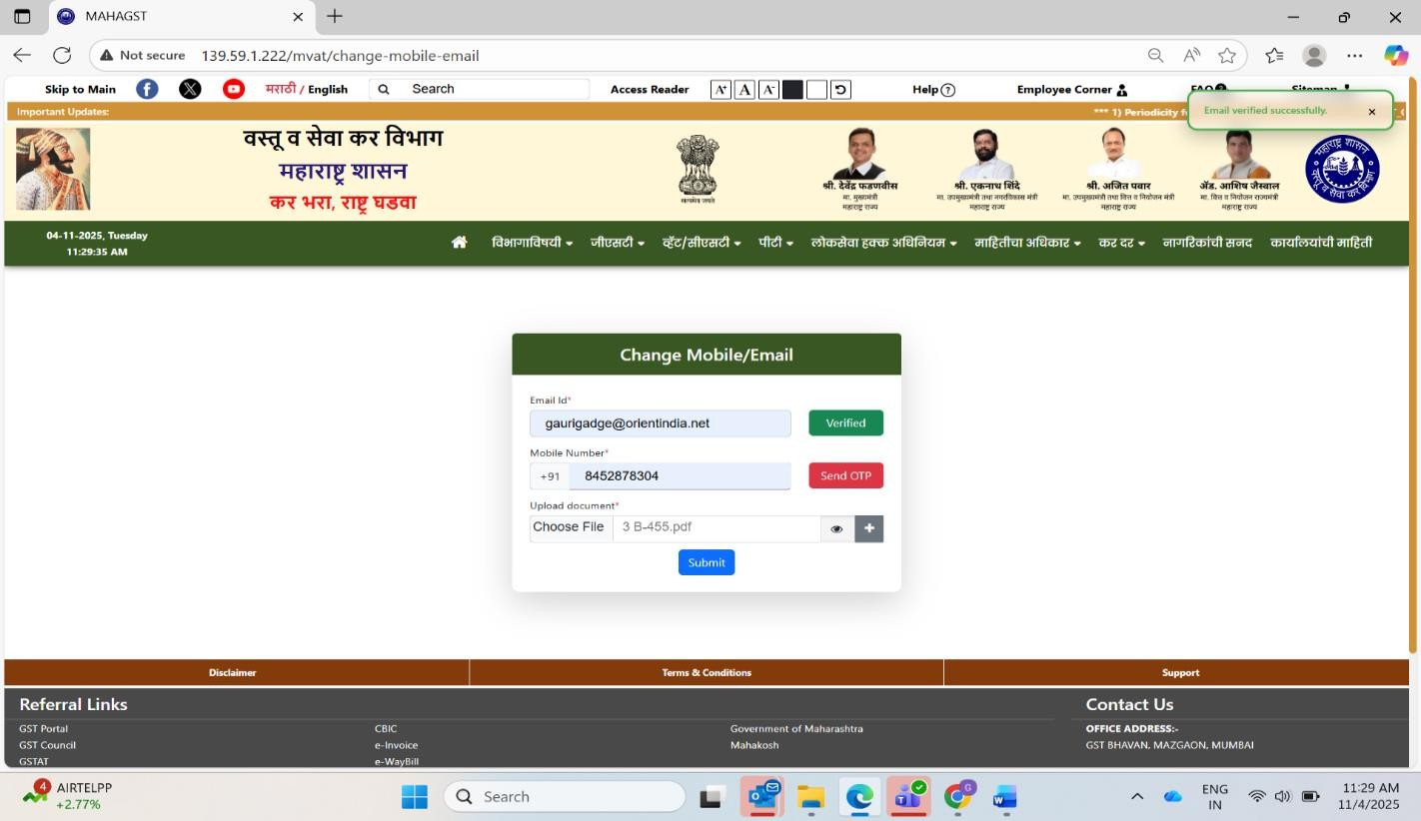

- Enter valid Mobile No.
  - click on send OTP and verify it. Once verified, the field will display a green “Verified” status.
  - Click on choose file to upload document.
1)Authorization from the registered dealer to update mobile no and Email ID.
2) Aadhar card/PAN card copy of applicant.
  - Click on Submit.

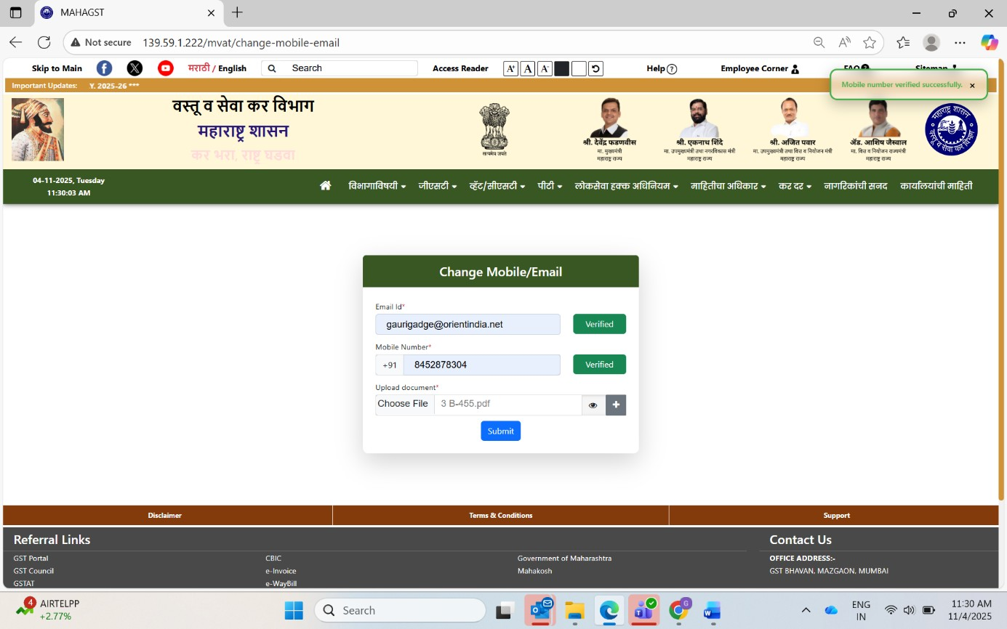

If you do not know your TIN then click on Doesn’t know TIN?

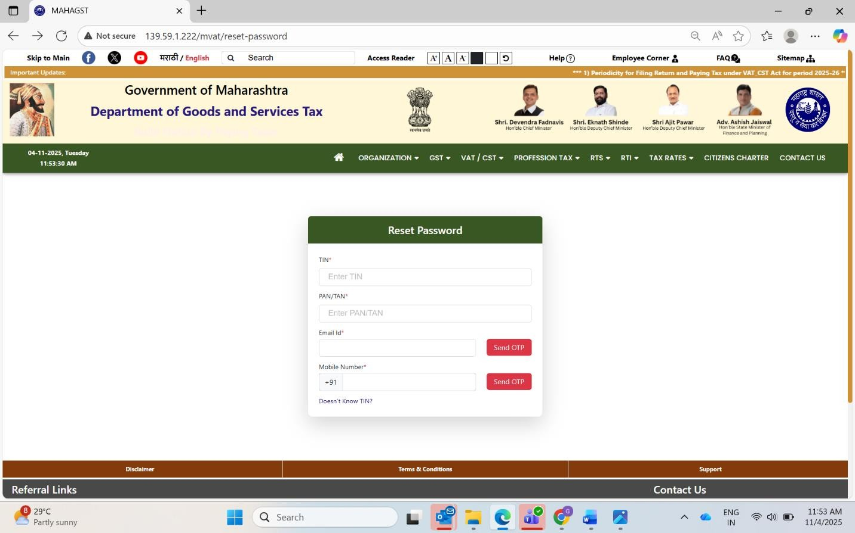
- Enter PAN/TAN
- Enter Email ID and verify it.
- Enter Mobile No and verify it.

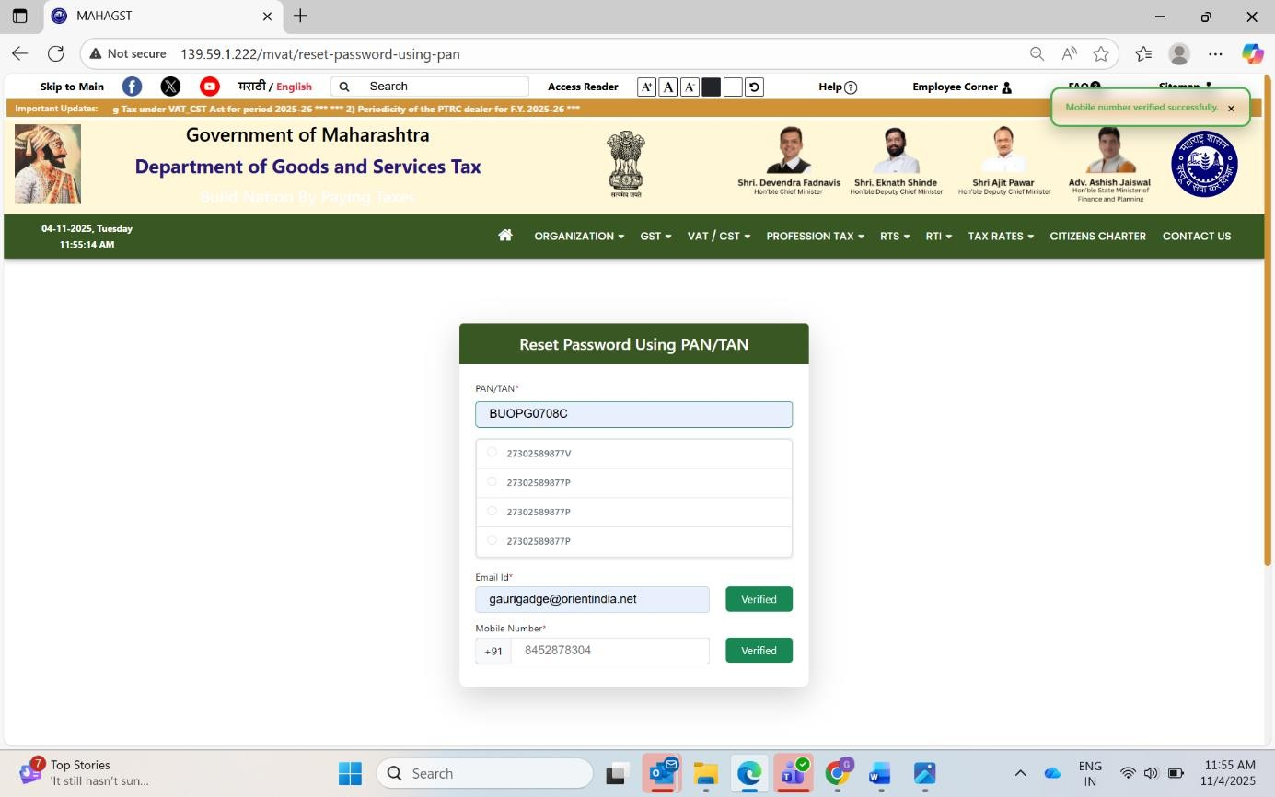

THANK YOU

